LAB 04 – Deep Learning  
  
**8) yolo_anchors.txt contains 10 values. They can be considered as height and width of 5 anchor boxes. What is the advantage of using such anchor boxes? What was the method used to determine the sizes of these anchor boxes? Give the answers to these questions in the word file.**  
  
Advantage of Using Anchor Boxes

* **Detection of Multiple Objects**: Anchor boxes allow the model to predict multiple bounding boxes for objects within the same grid cell.
* **Better Handling of Various Object Sizes**: By using multiple anchor boxes with different aspect ratios and sizes, the model can better predict objects of varying scales and shapes, which improves accuracy in detecting smaller or unusually shaped objects.
* **Efficiency in Training**: Anchor boxes enable the model to predict bounding boxes by focusing on refining the dimensions and position of these predefined boxes.

Method Used to Determine Anchor Box Sizes

* **Data Collection**: All bounding boxes from the training data are collected. Each bounding box is represented by its width and height.
* **K-means Clustering:** The K-means algorithm is applied to these bounding box dimensions. The number of clusters (K) is set to the number of anchor boxes you want

1. **Download the output images zip file from the google drive and observe the bounding boxes in the autonomous driving dataset (i.e., 21 images from 0100.jpg to 0120.jpg). Select 2 images from these 21 images and,**
   * **Write what you observe regarding correctly detected objects, incorrectly detected objects, undetected objects and incorrect bounding boxes in the word file.**
   * **Include these output 2 images as well as the original 2 images in the word file.**

Correctly Detected Objects

* Objects that are accurately identified and bounded by the predicted boxes with high confidence scores.

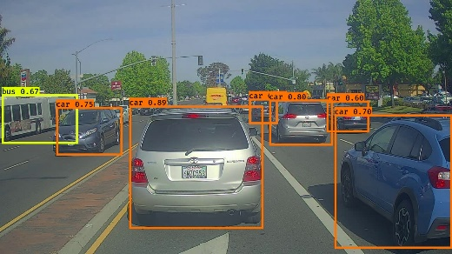

Incorrectly Detected Objects

* Objects that are identified but with errors in bounding box placement or classification.

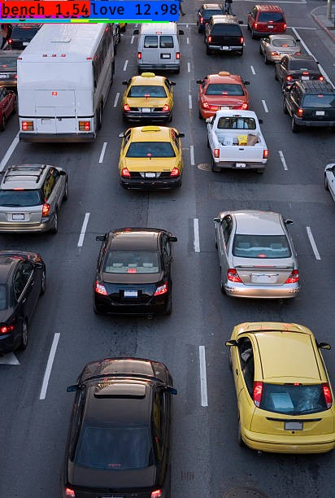

Undetected Objects

* Objects present in the image that are not identified by the model.

